34. To store multiple data items in a single variable we use a list. Describe the list of items which we use during the time of travel. Implement it in both ordered and unordered lists.
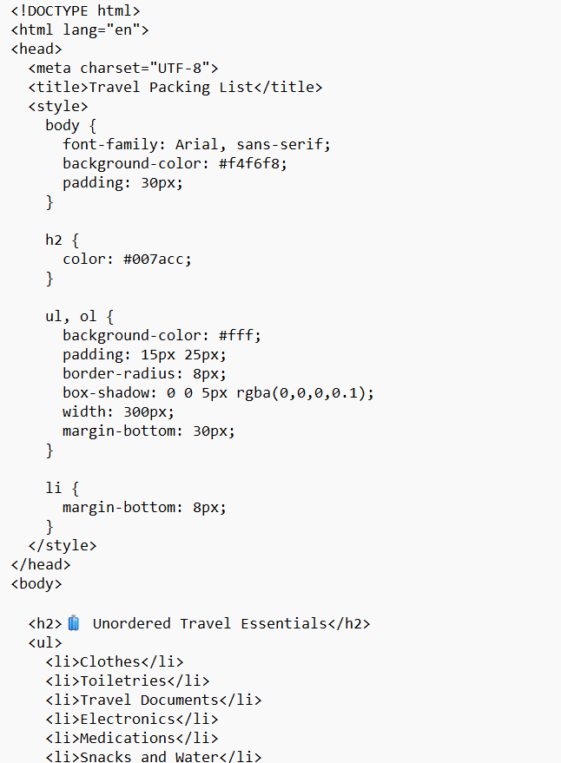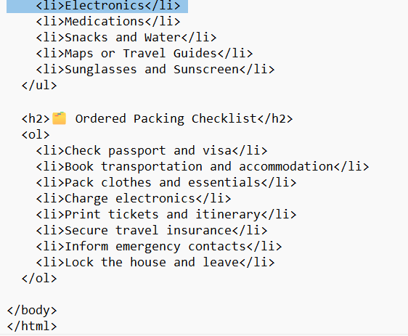output
